EX15-Create a Cloning of a VM and Test it by loading the Previous Version/Cloned VM

PROCEDURE:

Step1:To clone the virtual machine we need a virtual machine and go to vm and select clone 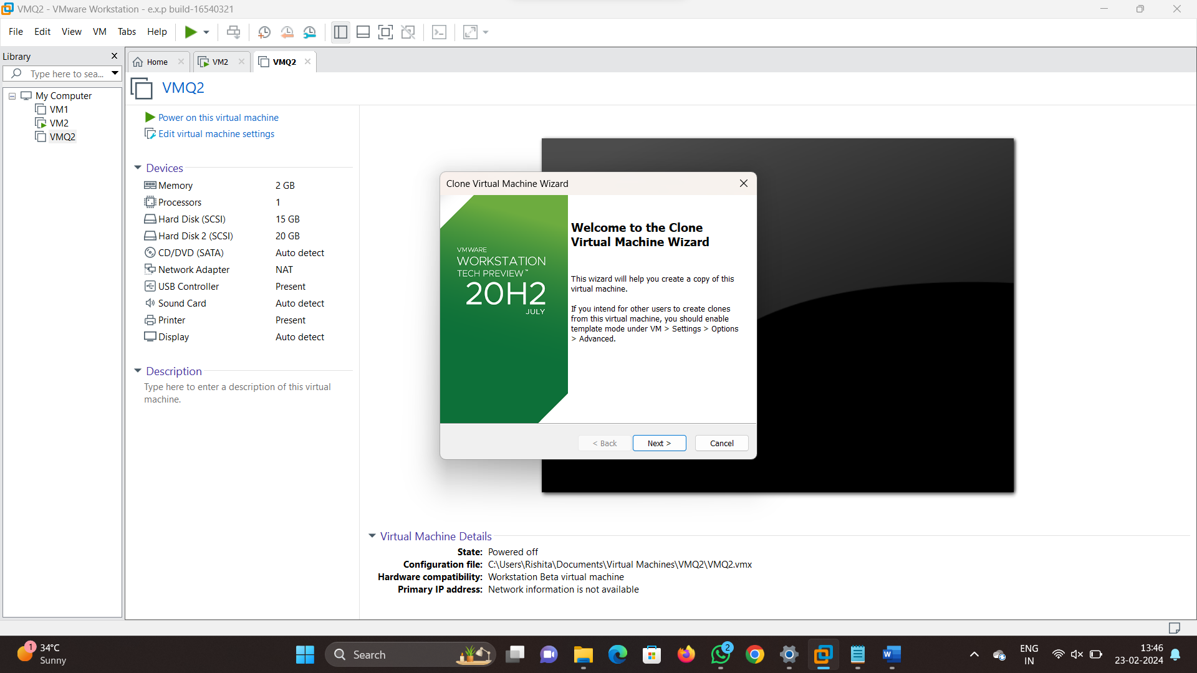

Step 2: select the name of the clone virtual machine 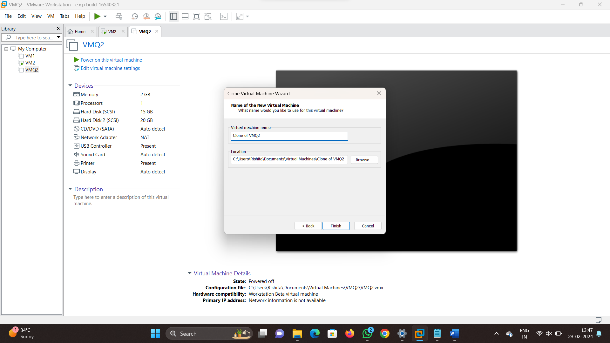

Step3: now click ok and finish all the process will be successful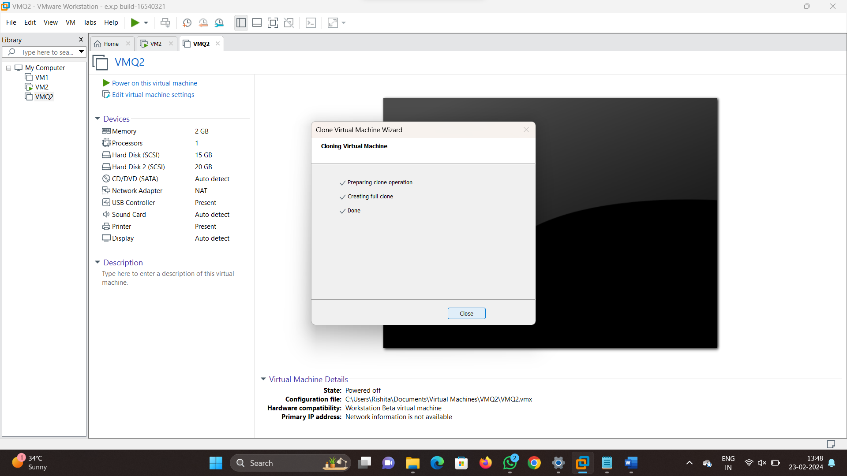

Step 4:Now the clone is created for our virtual machine

